Objectives

* Inheritance and TKINTER

**There are 7 Exercises, each worth 14.2%.**

**Inheritance** allows a new class to extend an existing class. The new class **inherits** the members of the class it **extends**. Inheritance allows to inheritance of attributes and methods from a parent class to a child class or classes.

These examples demonstrate the concept of inheritance in Python, where classes inherit properties and methods from their parent class(es) and can also override or add new functionality.

**Project #1**

**Project #2**

**Project #3**

An object inherited from two different classes.

**Challenge Exercise #1:** continuing from project #3, add the 3rd animal and print screen the results with the code below:

**#1 Print screen the output with the code below here**

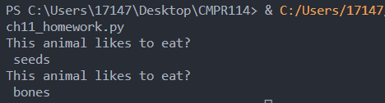

Code:

class AnimalType:

def eats(self):

print("This animal likes to eat? ")

class rabbits(AnimalType):

def munch(self):

print(" carrots")

class birds(AnimalType):

def munch1(self):

print(" seeds ")

class dogs(AnimalType):

def munch(self):

print(" bones")

BirdObject = AnimalType()

BirdObject = birds()

BirdObject.eats()

BirdObject.munch1()

DogObject = dogs()

DogObject.eats()

DogObject.munch()

**Project #4:** this example is using the super keyword to inherit attributes and arguments.

__init__ method initializes object attributes so they can be shared throughout the program

Entering information and passing the attributes to parameters. **(Enter lines 13-16 and 30-33)**

**Challenge Exercise #2:** Continuing from project #4 add to the super constructor (see line 23) and add the address, city, state, and zip code) for the Student and Teacher. Print screen below.

**#2 Print screen the output with the code below here**

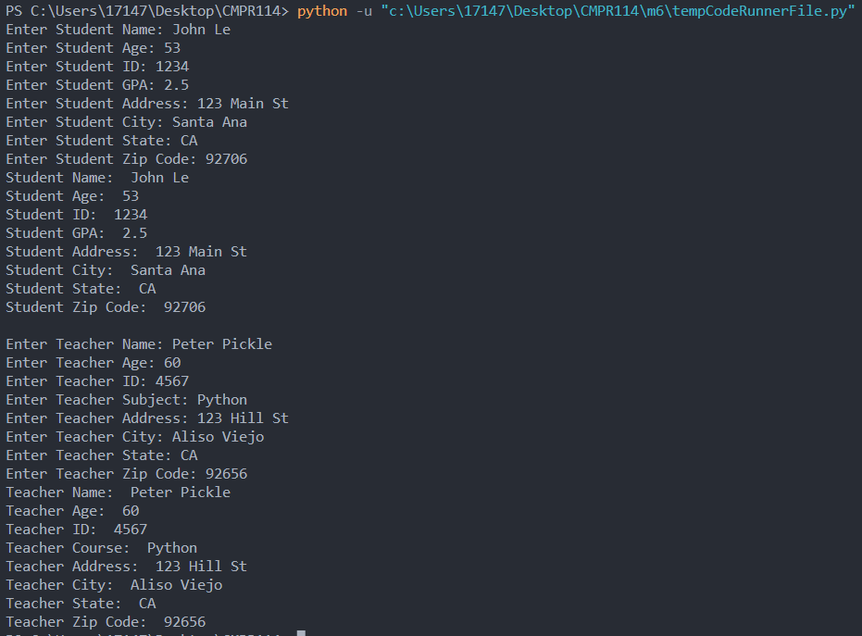

Code:

class person:

def __init__(self, name, age):

self.name = name

self.age = age

class student(person):

def __init__(self, name, age, studentid, gpa, address, city, state, zipcode):

#get input

name = input("Enter Student Name: ")

age = input("Enter Student Age: ")

studentid = input("Enter Student ID: ")

gpa = input("Enter Student GPA: ")

address = input("Enter Student Address: ")

city = input("Enter Student City: ")

state = input("Enter Student State: ")

zipcode = input("Enter Student Zip Code: ")

super().__init__(name, age)

self.studentid = studentid

self.gpa = gpa

self.address = address

self.city = city

self.state = state

self.zipcode = zipcode

class teacher(person):

def __init__(self, name, age, teacherid, subject, address, city, state, zipcode):

name = input("Enter Teacher Name: ")

age = input("Enter Teacher Age: ")

teacherid = input("Enter Teacher ID: ")

subject = input("Enter Teacher Subject: ")

address = input("Enter Teacher Address: ")

city = input("Enter Teacher City: ")

state = input("Enter Teacher State: ")

zipcode = input("Enter Teacher Zip Code: ")

super().__init__(name, age)

self.teacherid = teacherid

self.subject = subject

self.address = address

self.city = city

self.state = state

self.zipcode = zipcode

student1 = student("Jane Doe", 25,777, 3.8, "", "", "", "")

print(" ")

print("Student Name: ", student1.name)

print("Student Age: ", student1.age)

print("Student ID: ", student1.studentid)

print("Student GPA: ", student1.gpa)

print("Student Address: ", student1.address)

print("Student City: ", student1.city)

print("Student State: ", student1.state)

print("Student Zip Code: ", student1.zipcode)

print(" ")

teacher1 = teacher("Ms. Cantor", 45, 7, "Python", "", "", "", "")

print("Teacher Name: ", teacher1.name)

print("Teacher Age: ", teacher1.age)

print("Teacher ID: ", teacher1.teacherid)

print("Teacher Course: ", teacher1.subject)

print("Teacher Address: ", teacher1.address)

print("Teacher City: ", teacher1.city)

print("Teacher State: ", teacher1.state)

print("Teacher Zip Code: ", teacher1.zipcode)

**Project #5** (This is another example of two classes and inheritance, the car_demo class will inherit from the Automobiles class), the __init__ function is called automatically every time the class is used to create an object.

Create a new class and name its **vehicles** and type in the following code below:

Create a second class and label it as **car_demo**. This will act as the superclass or the main class that will inherit from the Automobile class.

**Challenge Exercise #3:** Continuing from project #5, print out another car’s description. See the example below:

**#3 print screen the output with the code below here (Need code for each class)**

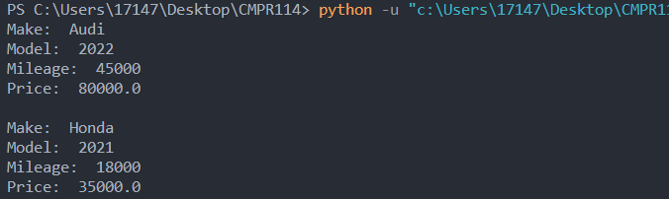

Code:

<From file vehicles>

class automobiles:

def __init__(self, make, model, mileage, price):

self.__make = make

self.__model = model

self.__mileage = mileage

self.__price = price

#mutator methods

def set_make(self, value):

self.__make = value

def set_make(self, value):

self.__model = value

def set_make(self, value):

self.__mileage = value

def set_make(self, value):

self.__price = value

#assessor methods

def get_make(self):

return self.__make

def get_model(self):

return self.__model

def get_mileage(self):

return self.__mileage

def get_price(self):

return self.__price

class car_demo(automobiles):

def __init__(self, make, model, mileage, price):

super().__init__(make, model, mileage, price)

import vehicles

def main():

used_car1 = vehicles.automobiles("Audi", 2022, 45000, 80000.0)

print("Make: ", used_car1.get_make())

print("Model: ", used_car1.get_model())

print("Mileage: ", used_car1.get_mileage())

print("Price: ", used_car1.get_price())

print(" ")

used_car2 = vehicles.automobiles("Honda", 2021, 18000, 35000.0)

print("Make: ", used_car2.get_make())

print("Model: ", used_car2.get_model())

print("Mileage: ", used_car2.get_mileage())

print("Price: ", used_car2.get_price())

print(" ")

main()

**Challenge Exercise #4:** now, add the number of doors for each car, be sure to add a mutator and an accessor for the door description.

**#4 Print screen the output with the code below here (Need code for each class)**

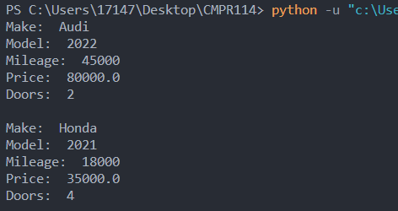

Code

<From file vehicles>

class automobiles:

def __init__(self, make, model, mileage, price, doors):

self.__make = make

self.__model = model

self.__mileage = mileage

self.__price = price

self.__doors = doors

#mutator methods

def set_make(self, value):

self.__make = value

def set_make(self, value):

self.__model = value

def set_make(self, value):

self.__mileage = value

def set_make(self, value):

self.__price = value

def set_doors(self, value):

self.__doors = value

#assessor methods

def get_make(self):

return self.__make

def get_model(self):

return self.__model

def get_mileage(self):

return self.__mileage

def get_price(self):

return self.__price

def get_doors(self):

return self.__doors

class car_demo(automobiles):

def __init__(self, make, model, mileage, price):

super().__init__(make, model, mileage, price)

import vehicles

def main():

used_car1 = vehicles.automobiles("Audi", 2022, 45000, 80000.0, 2)

print("Make: ", used_car1.get_make())

print("Model: ", used_car1.get_model())

print("Mileage: ", used_car1.get_mileage())

print("Price: ", used_car1.get_price())

print("Doors: ", used_car1.get_doors())

print(" ")

used_car2 = vehicles.automobiles("Honda", 2021, 18000, 35000.0, 4)

print("Make: ", used_car2.get_make())

print("Model: ", used_car2.get_model())

print("Mileage: ", used_car2.get_mileage())

print("Price: ", used_car2.get_price())

print("Doors: ", used_car2.get_doors())

print(" ")

main()

**Challenge Exercise #5:** See the UML diagram below and create the following three classes. The Insect class will be the main or the superclass and the bumblebee and grasshopper classes will act as the two sub-classes. Provide two characteristic behaviors for the bumblebee and grasshopper, be sure to use Mutator and Accessor methods for each class. Print or display the two characteristics of each insect below.

**#5 Print screen the output with the code below here (Need code for each class)**



Code:

class insects:

def __init__(self, size, legs):

self.__size = size

self.__legs = legs

#assessor methods

def get_size(self):

return self.__size

def get_legs(self):

return self.__legs

#mutator methods

def set_size(self, value):

self.__size = value

def set_legs(self, value):

self.__legs = value

class bumblebees(insects):

def __init__(self, size, legs, defense):

super().__init__(size, legs)

self.__defense = defense

def get_defense(self):

return self.__defense

def set_defense(self, value):

self.__defense = value

class grasshoppers(insects):

def __init__(self, size, legs, ability):

super().__init__(size, legs)

self.__ability = ability

def get_ability(self):

return self.__ability

def set_defense(self, value):

self.__ability = value

bbee = bumblebees(5, 6, "sting")

print(f"Bumblebees are {bbee.get_size()} cm and {bbee.get_legs()} legs and can {bbee.get_defense()} you when threaten.")

ghop = grasshoppers(7,6, "jump")

print(f"Grasshoppers are {ghop.get_size()} cm and {ghop.get_legs()} legs and can {ghop.get_ability()} real high.")

**Project #6 (Inheritance using TKINTER).**

he super() function is used to call a method from the parent class. In our example, super().__init__() is called within the __init__() method of both EmployeeForm and ManagerForm. This allows the parent class's __init__() method to be executed before the child class's specific code.

Inheritance is a mechanism in object-oriented programming that allows a class to inherit properties and methods from another class. In our code, ManagerForm inherits from EmployeeForm, denoted by class ManagerForm(EmployeeForm):. This means ManagerForm has access to all the attributes and methods defined in EmployeeForm, along with the ability to add or override them as needed.

By calling super().__init__() in the child class's __init__() method, we ensure that the parent class's initialization is performed before any additional customization specific to the child class. This allows us to reuse code and extend the functionality of the parent class in the child class.

**#6 Print screen the output with the code below here**

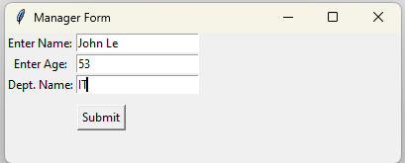

Code:

import tkinter as tk

class EmployeeForm(tk.Tk):

def __init__(self):

super().__init__()

self.title("Employee Form")

self.geometry("300x200")

self.label_name = tk.Label(self, text = "Enter Name:")

self.label_name.grid(row = 0, column = 0)

self.entry_name = tk.Entry(self)

self.entry_name.grid(row = 0, column = 1)

self.label_age = tk.Label(self, text = "Enter Age:")

self.label_age.grid(row = 1, column = 0)

self.entry_age = tk.Entry(self)

self.entry_age.grid(row = 1, column = 1)

self.btnSubmit = tk.Button(self, text = "Submit", command = self.submit)

self.btnSubmit.grid(row = 4, columnspan = 2, pady = 10)

def submit(self):

name = self.entry_name.get()

age = self.entry_age.get()

self.display_employee_info(name,age)

def display_employee_info(self, name, age):

info_window = tk.Toplevel(self)

info_window.title("Employee Information")

info_window.geometry("300x100")

infolbl = tk.Label(info_window, text = "Emp Info")

infolbl.pack(pady = 10)

namelbl = tk.Label(info_window, text = f"Name: {name}")

namelbl.pack()

agelbl = tk.Label(info_window, text = f"Age: {age}")

agelbl.pack()

class ManagerForm(EmployeeForm):

def __init__(self):

super().__init__()

self.title("Manager Form")

self.geometry("400x250")

self.deptlbl = tk.Label(self, text = "Dept. Name:")

self.deptlbl.grid(row = 2, column = 0)

self.deptentry = tk.Entry(self)

self.deptentry.grid(row = 2, column = 1)

def submit(self):

name = self.entry_name.get()

age = self.entry_age.get()

dept = self.deptentry.get()

self.display_employee_info(name, age, dept)

def display_employee_info(self, name, age, dept):

info_window = tk.Toplevel(self)

info_window.title("Manager Info")

#info_window.geometry("300x100")

#info_window.pack(pady = 10)

lblname = tk.Label(info_window, text = f"Name: {name}")

lblname.pack()

lblage = tk.Label(info_window, text = f"Age: {age}")

lblage.pack()

lbldept = tk.Label(info_window, text = f"Dept: {dept}")

lbldept.pack()

if __name__ == "__main__":

app = ManagerForm()

app.mainloop()

**Project #7 (Inheritance using TKINTER).**

**#7 Print screen the output (for each form) with the code below here.**

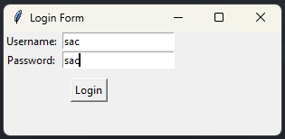

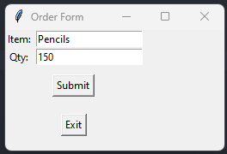



Code:

import tkinter as tk

class loginform(tk.Tk):

def __init__(self):

super().__init__()

self.title("Login Form")

self.geometry("200x100")

self.lblusername = tk.Label(self, text="Username: ")

self.lblusername.grid(row=0, column=0)

self.txtusername = tk.Entry(self)

self.txtusername.grid(row=0, column=1)

self.lblpassword = tk.Label(self, text="Password: ")

self.lblpassword.grid(row=1, column=0)

self.txtpassword = tk.Entry(self)

self.txtpassword.grid(row=1, column=1)

self.btnLogin = tk.Button(self, text="Login", command=self.login)

self.btnLogin.grid(row=2, columnspan=2, pady=10)

def login(self):

username = self.txtusername.get()

password = self.txtpassword.get()

if username == "sac" and password == "sac":

self.withdraw()

ordform = orderform(self)

ordform.mainloop()

else:

error_win = tk.Toplevel()

error_win.title("Login Error")

lblError = tk.Label(error_win, text="Invalid username or password.")

lblError.pack(pady=10)

class orderform(tk.Tk):

def __init__(self, loginform):

super().__init__()

self.title("Order Form")

self.login_form = loginform

self.lblitem = tk.Label(self, text="Item: ")

self.lblitem.grid(row=0, column=0)

self.txtitem = tk.Entry(self)

self.txtitem.grid(row=0, column=1)

self.lblqty = tk.Label(self, text="Qty: ")

self.lblqty.grid(row=1, column=0)

self.txtqty = tk.Entry(self)

self.txtqty.grid(row=1, column=1)

self.btnSubmit = tk.Button(self, text="Submit", command=self.submit)

self.btnSubmit.grid(row=2, columnspan=2, pady=10)

self.btnExit = tk.Button(self, text="Exit", command=self.exit)

self.btnExit.grid(row=3, columnspan=2, pady=10)

def submit(self):

item = self.txtitem.get()

qty = self.txtqty.get()

print(f"Order placed: Item={item}, Quantity={qty}")

def exit(self):

self.withdraw()

self.login_form.deiconify()

if __name__ == "__main__":

login_form = loginform()

login_form.mainloop()

**Submit this document to the Module 6 class exercise.**